Control of Steward Platform (AIE)

A Steward platform is a robotic manipulator used to achieve 6 degrees of freedom: Yaw, pitch, roll, x, y, z. This project will use this platform as a dynamic landing pad for offshore inspection drones, such that the drones can safely land on the service ship, despite the ship’s dynamic motion. The movable platform can be controlled to either be stationary relative to the drone or used to catch/align itself to the drone.
The project will use Matlab/Simulink to send and receive sensor and motor signals from a Steward platform setup located in the offshore lab of Aalborg University Esbjerg. The test setup is already constructed and ready for control implementation via Simulink desktop real time.
The project can include:
- Modeling of the Steward platform including both static inverse kinematics and dynamics of the actuator.
- Control development (6xPID).
- Investigate sensors and actuators, their signals, conversions, advantages, limitations.
- Signal processing
- Implement the developed control to the test setup.
- Sensors and instrumentation to allow for drone detection, alignment, and attach/deploy mechanism.
- Test and validate your controller.
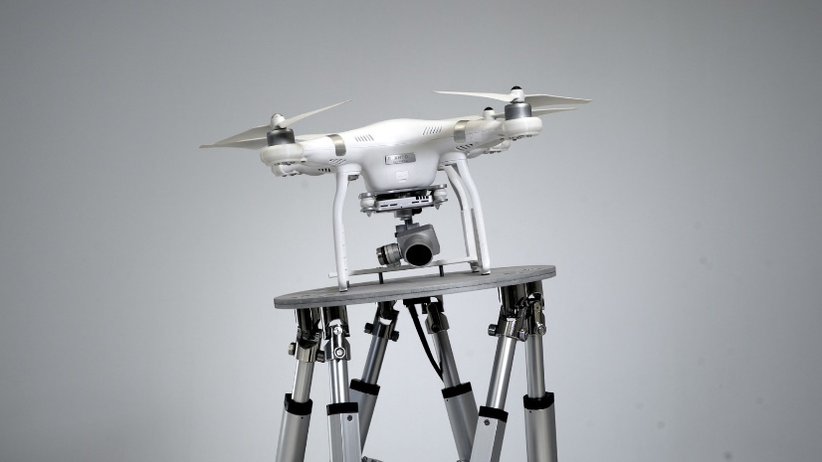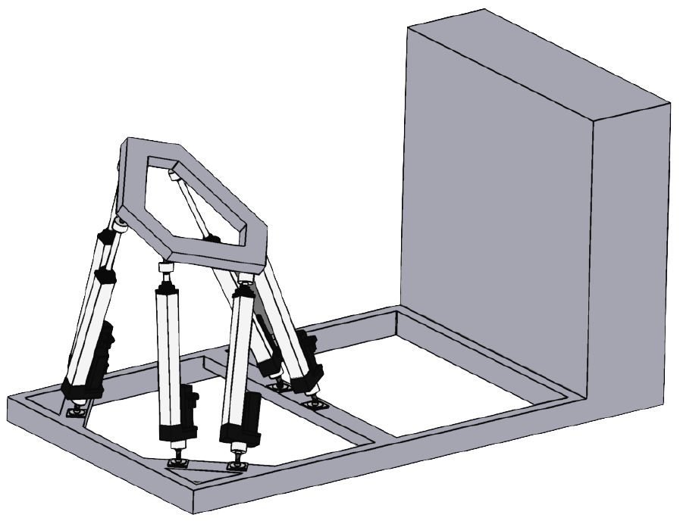

This project will be supervised by:
- Mads V. Bram: mvb@energy.aau.dk AAU
* This project does not suit all student groups as it is more ambitious + workload; agreement with Mads is necessary.

